**ASSIGNMENT – 1**

**TEMPERATURE AND PIR SENSOR BASED BUZZER ALARM**

**VENGAM SASIKUMAR**

**111519106172**

**CIRCUIT:**

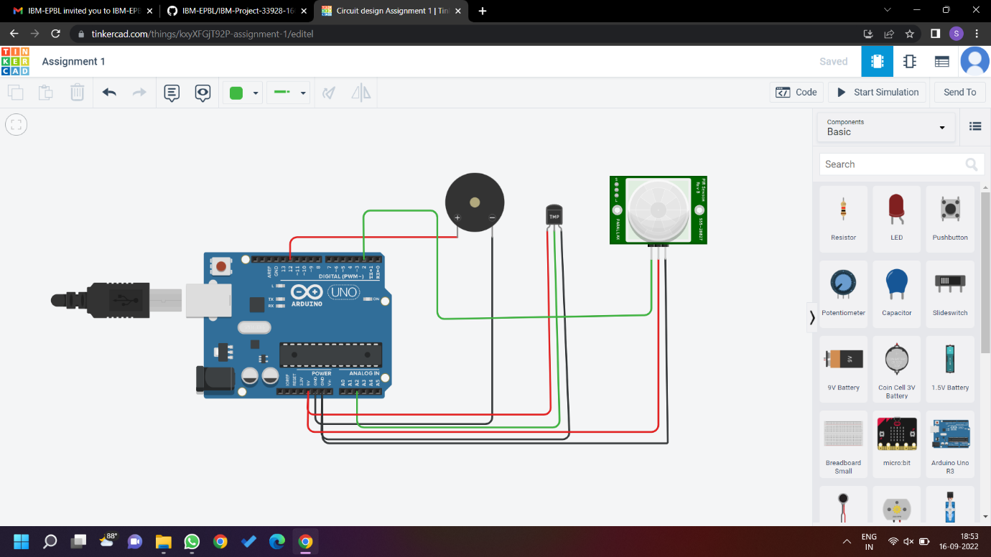

**CODE:**

**void setup()**

**{**

**Serial.begin(9600);**

**pinMode(2,INPUT);**

**pinMode(12,OUTPUT);**

**}**

**void loop()**

**{**

**int motion=digitalRead(2);**

**if(motion==1)**

**{**

**Serial.println("Motion is detected !");**

**tone(12,10);**

**delay(1000);**

**noTone(12);**

**delay(3000);**

**}**

**else**

**{**

**Serial.println("No Motion !!!");**

**delay(1000);**

**}**

**double data=analogRead(A2);**

**double temp=(((data/1024)*5)-0.5)*100;**

**if(temp>60)**

**{**

**Serial.println("Temperature is greater than 60 degrees !");**

**Serial.println(temp);**

**tone(12,100);**

**delay(1000);**

**noTone(12);**

**delay(3000);**

**}**

**else**

**{**

**Serial.println("Temperature is less than 60 degrees !!!");**

**Serial.println(temp);**

**delay(1000);**

**}**

**}**